

Semester One Examination, 2020

Question/Answer booklet

MATHEMATICS METHODS
UNIT 1

Section Two:

Calculator-assumed

Your Name

Your Teacher’s Name

Time allowed for this section
Reading time before commencing work: ten minutes
Working time: one hundred minutes

Materials required/recommended for this section
To be provided by the supervisor
This Question/Answer booklet
Formula sheet (retained from Section One)

To be provided by the candidate
Standard items: pens (blue/black preferred), pencils (including coloured), sharpener, correction fluid/tape, eraser, ruler, highlighters

Special items: drawing instruments, templates, notes on two unfolded sheets of A4 paper, and up to three calculators approved for use in this examination

Important note to candidates
No other items may be taken into the examination room. It is your responsibility to ensure that you do not have any unauthorised material. If you have any unauthorised material with you, hand it to the supervisor before reading any further.
Question | Marks | Max | Question | Marks | Max
9 |  | 9 | 17 |  | 7
10 |  | 8 | 18 |  | 11
11 |  | 5 | 19 |  | 6
12 |  | 8 | 20 |  | 8
13 |  | 7 | 21 |  | 6
14 |  | 10
15 |  | 5
16 |  | 10

Structure of this paper

Section | Number of questions available | Number of questions to be answered | Working time (minutes) | Marks available | Percentage of examination
Section One:  Calculator-free | 8 | 8 | 50 | 50 | 33
Section Two:  Calculator-assumed | 13 | 13 | 100 | 100 | 67
 |  |  |  | Total | 100
Instructions to candidates

- The rules for the conduct of the Western Australian Certificate of Education ATAR course examinations are detailed in the Year 12 Information Handbook 2020. Sitting this examination implies that you agree to abide by these rules.

- Write your answers in this Question/Answer booklet.

- You must be careful to confine your answers to the specific questions asked and to follow any instructions that are specific to a particular question.

- Additional pages for the use of planning your answer to a question or continuing your answer to a question have been provided at the end of this Question/Answer booklet. If you use the space to continue an answer, indicate in the original answer space where the answer is continued, i.e. give the page number.

- Show all your working clearly. Your working should be in sufficient detail to allow your answers to be checked readily and for marks to be awarded for reasoning. Incorrect answers given without supporting reasoning cannot be allocated any marks. For any question or part question worth more than two marks, valid working or justification is required to receive full marks. If you repeat any question, ensure that you cancel the answer you do not wish to have marked.

- It is recommended that you do not use pencil, except in diagrams.

- The Formula sheet is not to be handed in with your Question/Answer booklet.

See Next Page

Section Two: Calculator-assumed (100 Marks)

This section has thirteen (13) questions. Answer all questions. Write your answers in the spaces provided.

Spare pages are included at the end of this booklet. They can be used for planning your responses and/or as additional space if required to continue an answer.
● Planning: If you use the spare pages for planning, indicate this clearly at the top of the page.
● Continuing an answer: If you need to use the space to continue an answer, indicate in the original answer space where the answer is continued, i.e. give the page number. Fill in the number of the question that you are continuing to answer at the top of the page.

Working time: 100 minutes.

Question 9 {1.1.23, 1.1.24, 1.1.25} (9 marks)

- Circle the diagrams that show functions. (2 marks)

(i)  1  2  3  4  1  1  2  3  4 | 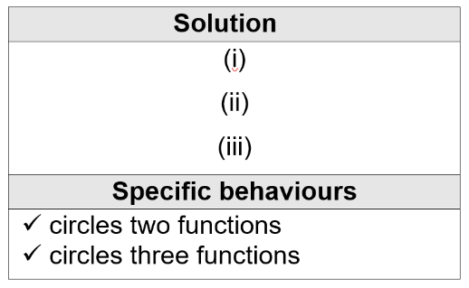
(ii)
34
56
1

1
1
1

6
3
7
1

(iii)
5
6
7
8

1
2
3
4

(iv)
6
8
9
2
7

1
3
2
7

- State the domain and range for the following functions. (4 marks)

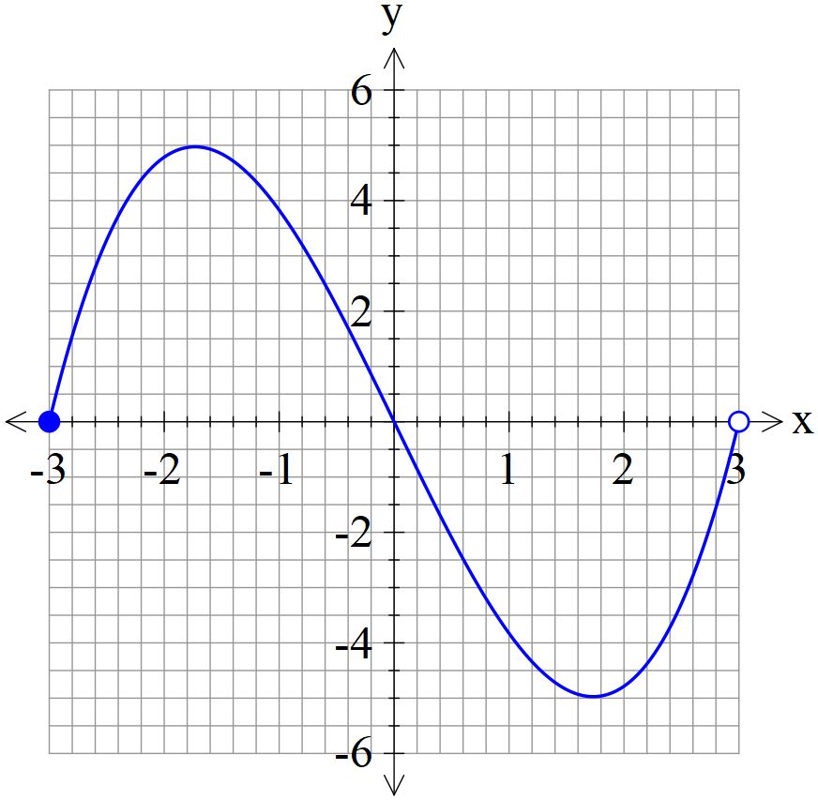 | Solution  Domain:  $$\left\{x∈R: -3≤x<3\right\}$$  Range:  $$\left\{y∈R: -5≤y≤5\right\}$$  Specific behaviours  correct domain  correct range

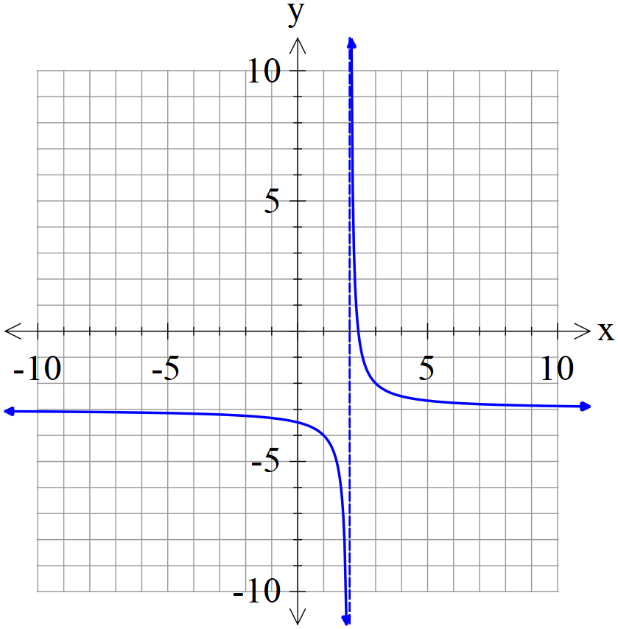 | Solution  Domain:  $$\left\{x∈R: x≠2\right\}$$  Range:  $$\left\{y∈R: y≠-3\right\}$$  Specific behaviours  correct domain  correct range

- If $f\left(x\right)=x^{2}+2x$ find (3 marks)
Solution
$$f\left(-1\right)={(-1)}^{2}+2×(-1)=-1$$
$$f\left(a\right)=a^{2}+2a$$
$$f\left(x+h\right)={(x+h)}^{2}+2(x+h)$$
Specific behaviours
correct value for $f\left(-1\right)$
correct expression for $f\left(a\right)$
correct expression for $f\left(x+h\right)$

- $f\left(-1\right)=$-1

- $f\left(a\right)= a^{2}+2a$

- $f\left(x+h\right)=$ ${\left(x+h\right)}^{2}+2(x+h)$

Question 10 {1.3.13, 1.3.15, 1.3.16} (8 marks)
In a school survey of 207 students in Year 11 and Year 12, it was observed that 77 of the 102 Year 12 students studied Mathematics and the 10 students in Year 11 did not study Mathematics.

If one student is selected at random from those surveyed, determine the probability that
- they were in Year 11. (1 mark)

Solution
$$P(Year 11)=\frac{207-102}{207}=\frac{105}{207}$$
Specific behaviours
correct probability

- they studied Mathematics. (1 mark)

Solution
$$P(Maths)=\frac{77+(105-10)}{207}=\frac{172}{207}$$
Specific behaviours
correct probability

- they were in Year 12 or studied Mathematics. (2 marks)

Solution
$$P(Year 12∪Maths)=\frac{102+172-77}{207}=\frac{197}{207}$$
Specific behaviours
uses inclusion-exclusion principle
correct probability

- They studied Mathematics given they were in Year 11. (2 marks)

Solution
$$P\left(Maths | Year 11\right)=\frac{95}{105}$$
Specific behaviours
correct numerator
correct denominator

- Without calculating any further probabilities, is there any indication that studying Mathematics is independent of Year? Justify your answer. (2 marks)

Solution
The choice of Mathematics is NOT independent of year.
As $P(Maths)=\frac{172}{207} ≈0.83$
but $P(Maths|Year 11)=\frac{95}{105}≈0.90$
Specific behaviours
states ‘not independent’
uses the rule P(A│B) = P(A)

Question 11 {1.1.3, 1.1.4, 1.1.5} (5 marks)

Consider the graph shown:
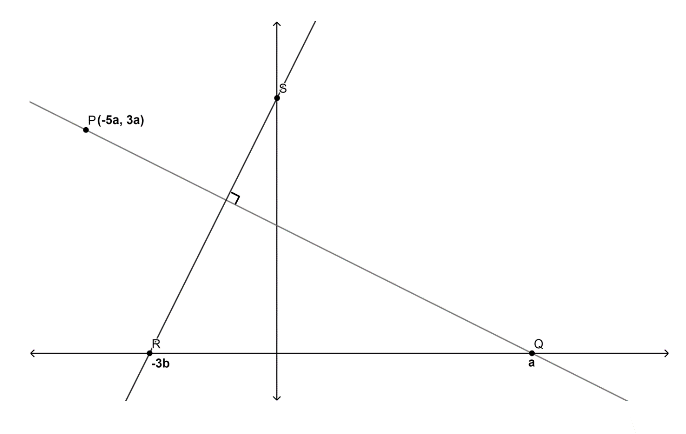
- Find the gradient of the line PQ. (2 marks)
Solution
$$m_{PQ}=\frac{3a-0}{-5a-a}=\frac{3a}{-6a}=-\frac{1}{2}$$
Specific behaviours
uses $\frac{rise}{run}$
correct gradient

- Find the equation of the line RS. (2 marks)
Solution
$$m_{RS}×m_{PQ}=-1$$
$${-\frac{1}{2}m}_{RS}=2⇒m_{RS}=2$$
$$y=2x+6b$$
Specific behaviours
determines gradient of line RS
determines equation of line RS

- Find the coordinates of point S. (1 mark)
Solution
$$S(0, 6b)$$
Specific behaviours
states the coordinates of S

Question 12 {1.1.7, 1.1.10, 1.1.12} (8 marks)
Use your ClassPad to display parabolas $f(x)$, $g(x)$ and $h\left(x\right)$ whose equations are
$$f(x)=-0.5x\left(x+2\right)$$
$$g(x)=-2x(x-4)$$
$h\left(x\right)$ $=x(x-1)$

- Write down a feature these three parabolas have in common. (1 mark)

Solution
$They all pass through (0, 0)$.
Specific behaviours
states parabolas pass through the origin

- Write down the turning point for each parabola and state its nature. (3 marks)

Solution
For $f(x)$, maximum turning point ($-1, 0.5)$
For $g(x)$, maximum turning point $(2, 8)$
For $h\left(x\right)$, minimum turning point $(0.5, -0.25)$
Specific behaviours
states maximum turning point and its coordinates for $f(x)$
states maximum turning point and its coordinates for $g(x)$
states minimum turning point and its coordinates for $h\left(x\right)$

- Write down the equation of $h\left(x\right)$ in turning point form and state the line of symmetry.
(2 marks)

Solution
$$h\left(x\right)=({x-0.5)}^{2}-0.25$$
$$x=0.5$$
Specific behaviours
expresses $h\left(x\right)$in turning point form
states equation for the line of symmetry

- If the graph of $h\left(x\right)$ is translated 2 units in the positive direction of the x axis and 2 units in the negative direction of the y axis, write down the new equation for $h\left(x\right)$ and state its new line of symmetry.
(2 marks)

Solution
$$h\left(x-2\right)-2={\left[(x-2)-0.5\right]}^{2}-0.25-2$$
$=({x-2.5)}^{2}-2.25$
$$x=2.5$$
Specific behaviours
writes equation for $h\left(x\right)$ after the translations
states equation for the line of symmetry after the translations

Question 13 {1.1.15} (7 marks)
Sketch the graphs of the following functions. Draw and label the key features, including x- and y-intercepts, vertices, asymptotes (if relevant), showing correct general shape and behaviour.
- $y= \frac{4}{x}-5$ (4 marks)
Solution
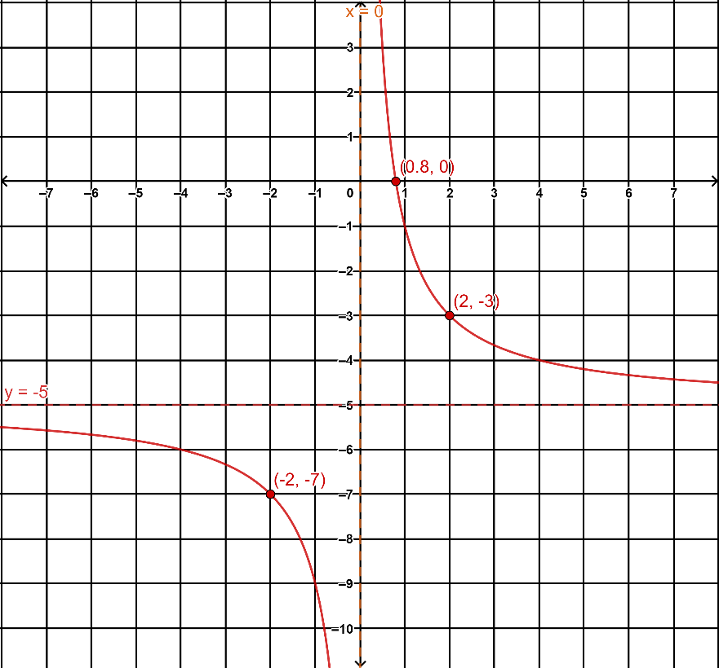
Specific behaviours
draws and labels horizontal asymptote$y=-5$
draws and labels vertical asymptote $x=0$
Plots and labels x-intercept $(0.8, 0)$ or $(-2, -7)$ & $(2, -3)$
correct shape with smooth curves

- $y=3 \sqrt{x}$ (3 marks)

Solution
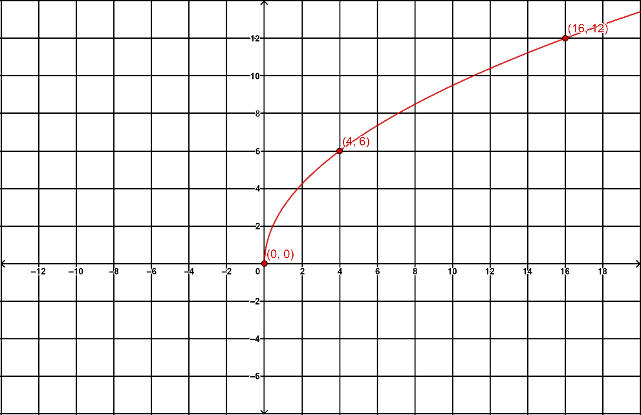
Specific behaviours
states at (0, 0)
plots and labels at least one point on the graph (4, 6), (16, 12)
correct shape with smooth curve
Question 14 {1.1.18} (10 marks)
- Sketch the graph of each of the following function, labelling intercepts, point of inflection and showing the shape and behaviour as $x→ ∞$ and $x→-∞$.
- $y = -x^{3}$ (2 marks)
Solution
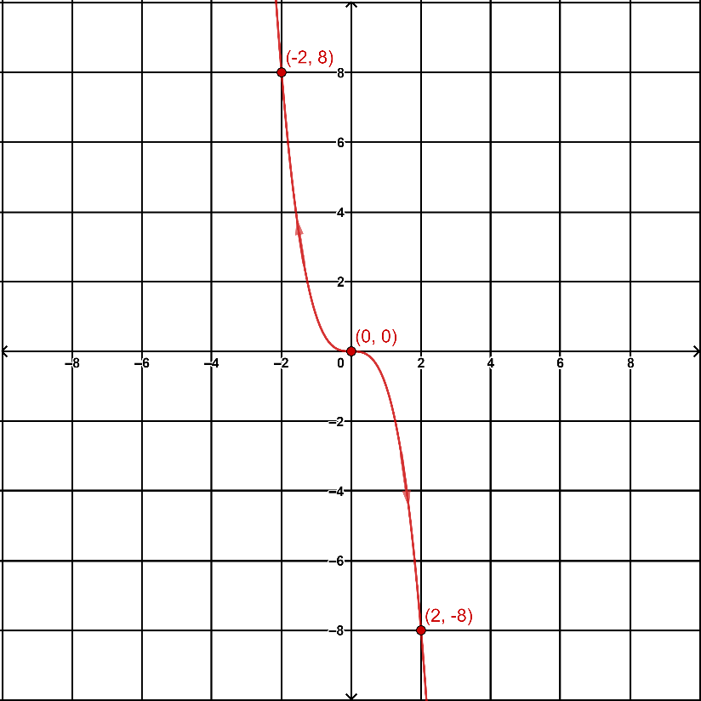
Specific behaviours
plots and label the point of inflection (0, 0)
current shape with smooth curve

- $y=2{(3-x)}^{3} + 4$ (3 marks)
Solution
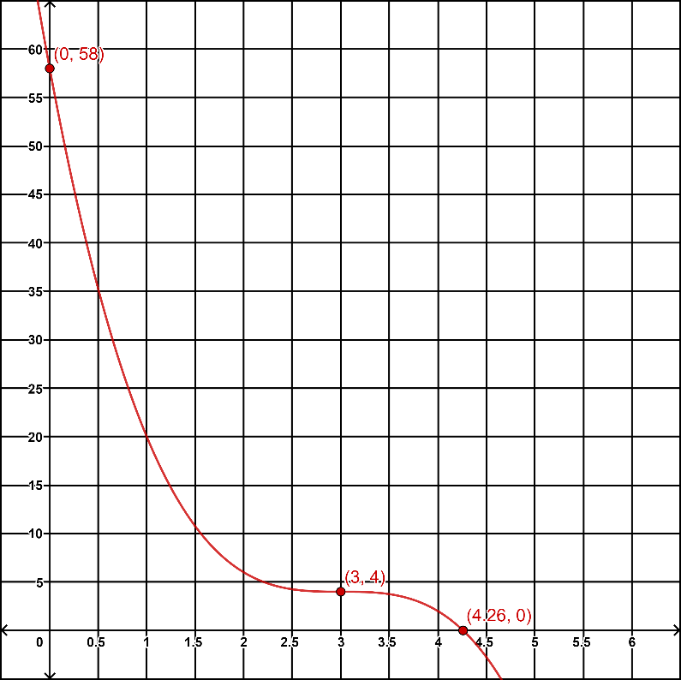
Specific behaviours
plots and labels y-intercept (0, 58)
plots and labels point of inflection (3, 4)
plots and labels x-intercept (4.26, 0)

- Express cubic function $y=-\frac{x^{3}}{2} + 2 x^{2} +2x - 8$ in its factorised form and sketch its graph, labelling all intercepts and using arrows to show its shape and general behaviour as $x →- ∞$ and$x →∞.$
(5 marks)

Solution
$$y=-\frac{1}{2}(x+2)(x-2)(x-4)$$
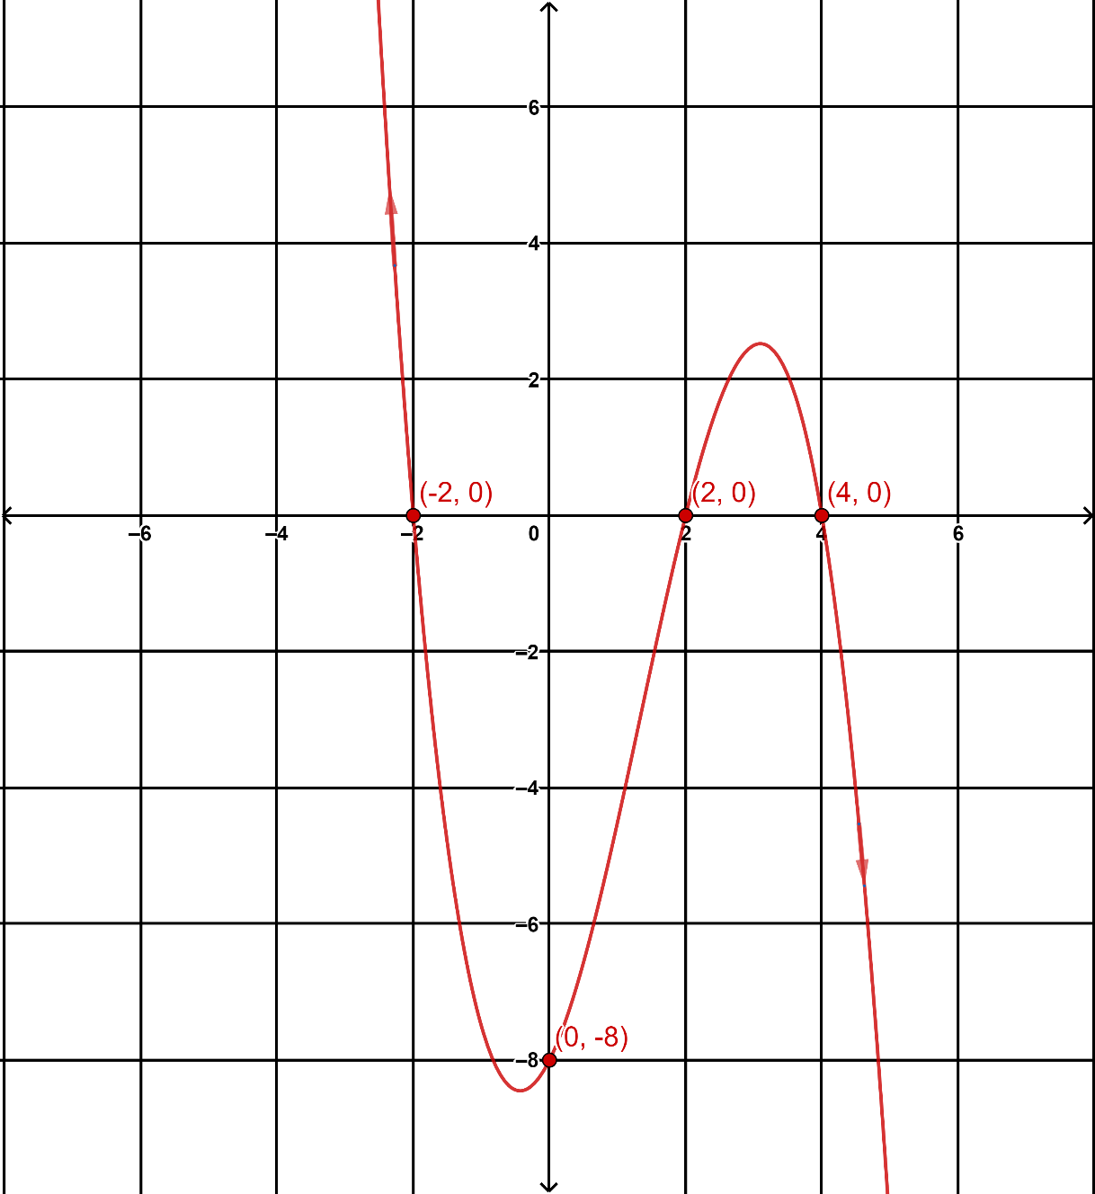
Specific behaviours
writes equation in factorised form
plots and labels all x-intercepts
plots and labels the y-intercept
uses arrows to show behaviour as $x →+/- ∞$
general shape with smooth curve

Question 15 {1.1.13} (5 marks)

An online company that sells onesies has modelled their expected number of daily sales (S) against the average daily temperature (T) in $℃$.
Their model has S as inversely proportional to $\sqrt{2T+16}$ for $-5≤T≤30$.
On a 10$℃$ day in August they sold 20 onesies.

- Determine the relationship between S and T. (3 marks)

Solution
$$S∝\frac{1}{\sqrt{2T+16}} ⇒S=\frac{k}{\sqrt{2T+16}}$$
$$20=\frac{k}{\sqrt{2×10+16}}⇒k=120$$
$$S=\frac{120}{\sqrt{2T+16}}$$
Specific behaviours
constructs equation for S
determines k
determines relationship between S and T

- Determine the number of expected sales tomorrow if the average forecasted temperature is 29. (2 marks)

Solution
$$S=\frac{120}{\sqrt{2×29+16}}=13.9 (1 d.p)$$
Hence, the number of expected sales is 14
Specific behaviours
substitutes $T=29$
states the number of expected sales as an integer

Question 16 {1.1.14} (10 marks)
- State all the asymptotes on each graph below then determine each equation of the rectangular hyperbola:
- (3 marks)
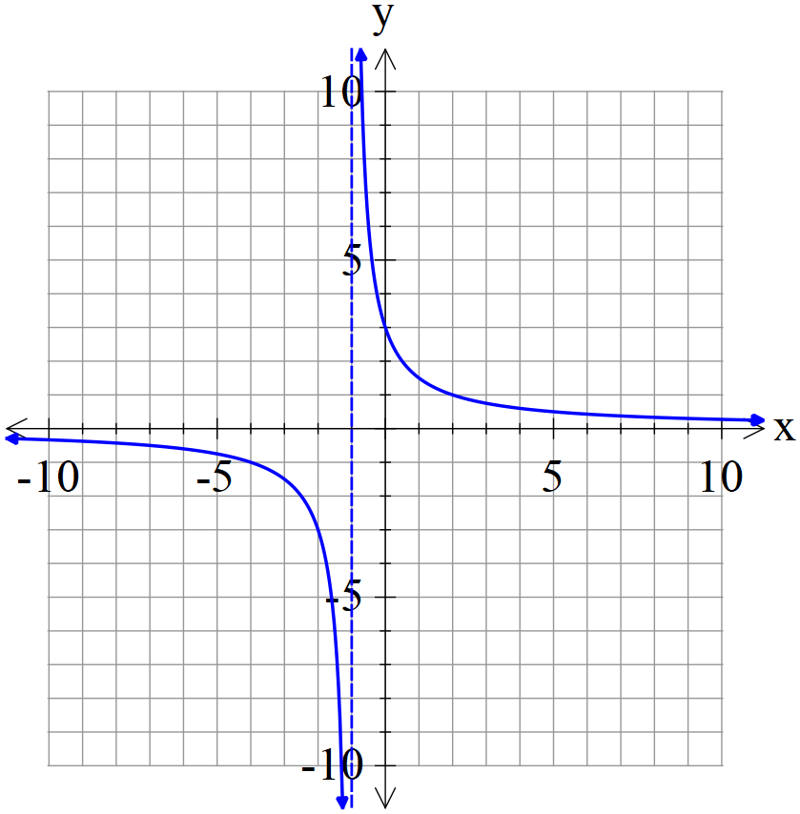
Solution
$$y=\frac{k}{x+1}$$
$$\frac{k}{0+1}=3⇒k=3$$
$$y=\frac{3}{x+1}$$
Specific behaviours
states asymptotes $x=-1$ & $y=0$
substitutes point and solves
states equation

- (3 marks)
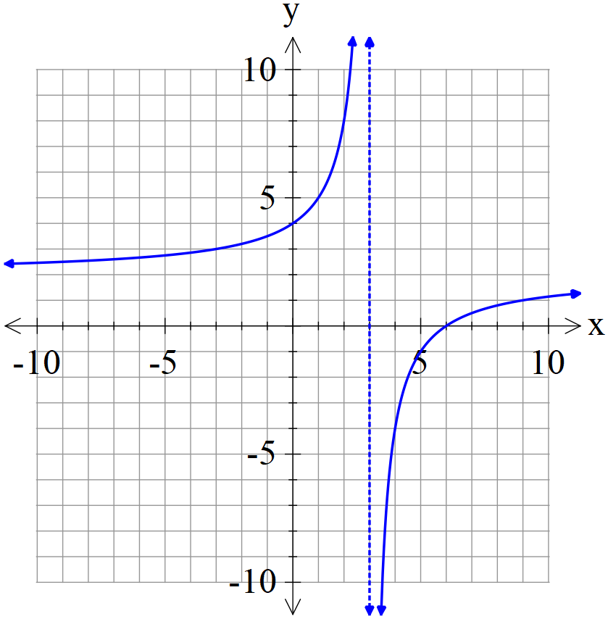
Solution
$$y=\frac{k}{x-3}+2$$
$$\frac{k}{0-3}+2=4⇒k=-6$$
$$y=\frac{-6}{x-3}+2$$
Specific behaviours
states asymptotes $x=3$ & $y=2$
substitutes point and solves
states equation

- Complete the table below.
- (4 marks)
Solution
Curve | x-intercept | y-intercept | Asymptote parallel to the
 |  |  | x-axis | y-axis
$$y=\frac{6}{x-2}-3$$ | $$(4, 0)$$ | $$(0, -6)$$ | $$y=-3$$ | $$x=2$$
$$y=\frac{-9}{x+3}$$ | None | $$(0, -3)$$ | $$y=0$$ | $$x=-3$$

Specific behaviours
correct x-intercepts
correct y-intercepts
correct horizontal asymptotes
correct vertical asymptotes
Question 17 {1.1.10} (7 marks)

A C-9 jet utilised by NASA enters a parabolic flight at an altitude of 9200m to simulate zero gravity. For the duration of the zero-gravity flight, its altitude $A$ in metres can be represented as a function of time $t$ in seconds as follows:

$$A(t)=at^{2}+bt+c$$

- Given that the function passes through the points $\left(2, 9400\right)$ and $\left(4, 9560\right)$, determine the values of $a$, $b$ and $c$. (3 marks)
Solution
$$A(0)=9200⇒c=9200$$
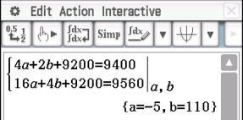
Specific behaviours
states value for c
states value for a
states value for b

- When is the maximum altitude reached by the jet? State the maximum altitude.
(2 marks)
Solution
$$A(t)=-{5x}^{2}+110x+9200$$
When $t=-\frac{110}{2×(-5)}=11s$
$$A(11)=-5{(11)}^{2}+110(11)+9200$$
$$=9805$$
Hence, the maximum altitude is 9805m at 11s
Specific behaviours
correct value for t at maximum altitude
correct value for A at maximum altitude

- Given that the plane exits the parabolic flight at the same altitude it begins at, what is the duration of the zero-gravity simulation? (2 marks)
Solution
$$A(t)=-{5x}^{2}+110x+9200=9200$$
$$t(t-22)=0$$
$$∴t=0 or 22$$
Hence, the duration is 22s
Specific behaviours
substitutes A(t) by 9200 and solves for t
states the duration

Question 18 {1.1.26, 1.1.27} (11 marks)
- Let $f(x)=x^{3}$
- What is the equation of the new function if $f(x)$ is translated 4 units to the right and 3 units down? What are the coordinates of the point of inflection?
(3 marks)
Solution
$$y={(x-4)}^{3}-3$$
Point of inflection is $(4, -3)$
Specific behaviours
writes equation for $f(x-4)-3$
states point of inflection for $f(x-4)-3$
- Find the coordinates of the point of inflection of the function $y=-\frac{1}{2}f(2x+1)$.
(2 marks)
Solution
$$-\frac{1}{2}f(2x+1)=-\frac{1}{2}f\left[2\left(x+\frac{1}{2}\right)\right]$$
Since the point of inflection for $f(x)$ is $(0, 0)$
$\left(-\frac{1}{2}, 0\right)$ is the point of inflection for $-\frac{1}{2}f(2x+1)$.
Specific behaviours
correct x value for the point of inflection for $-\frac{1}{2}f(2x+1)$
correct y value for the point of inflection for $-\frac{1}{2}f(2x+1)$.
- State the sequence of graphical transformation(s) which occurs if:
- $g(x)→g(2x-2)$ (2 marks)
Solution
If in factorised form $g\left[2(x-1)\right]$:  Horizontal dilation by scale factor $\frac{1}{2}$, then  horizontal translation to the right by 1. | If in expanded form$g(2x-2)$:  Horizontal translation to the right by 2, then  Horizontal dilation by scale factor $\frac{1}{2}$.
Specific behaviours
states horizontal dilation in correct order  states horizontal translation in correct order |  | Incorrect answer if student gives “horizontal  dilation by SF $\frac{1}{2}$” prior to “translate left by 2”.
- $h\left(x\right)→\frac{5}{2}h\left(\frac{2}{3}x+\frac{π}{3}\right)-1$ (4 marks)
Solution
If in factorised form $\frac{5}{2}h\left[\frac{2}{3}\left(x+\frac{π}{2}\right)\right]-1$:  ①Vertical dilation by scale factor $\frac{5}{2}$  ②Horizontal dilation by scale factor $\frac{3}{2}$  ③Horizontal translation to the left by $\frac{π}{2}$  ④Vertical translation down by 1 | If in expanded form $\frac{5}{2}h\left(\frac{2}{3}x+\frac{π}{3}\right)-1$  ①Vertical dilation by scale factor $\frac{5}{2}$  ②Horizontal translation to the left by $\frac{π}{3}$  ③Horizontal dilation by scale factor $\frac{3}{2}$  ④Vertical translation down by 1
Specific behaviours
states vertical dilation in correct order  states horizontal dilation in correct order  states horizontal translation in correct order  states vertical translation in correct order | For both versions, ①&② can switch, ③&④ can  switch. Incorrect answer if student gives “horizontal  dilation by SF $\frac{3}{2}$” prior to “translate left by $\frac{π}{3}$”.
Question 19 {1.1.26, 1.1.27} (6 marks)
The graph shows the function .
(a) Sketch the graph of . (3 marks)
Solution
Specific behaviours
starts at $(-7,-4)$
passes through $(0, 0)$
ends at $(3, 3)$
(b) Sketch the graph of . (3 marks)
Solution
Specific behaviours
starts at $(-5,-0.5)$
passes through $(-2,-2)$
ends at $(5,-4)$

Question 20 {1.3.11, 1.3.12, 1.3.17} (8 marks)
1000 people were studied to see if they contracted an illness (I) and whether they were vaccinated against it (V). 86 people caught the illness and 348 were vaccinated, including 1 person who caught the illness despite being vaccinated.

- Given that the above data is representative of a population, find the probability that a person randomly selected from the population:

    - is not vaccinated? (2 marks)
Solution
$$P\left(\overline{V}\right)=1-P(V)=1-\frac{348}{1000}$$
$$=\frac{652}{1000}$$
Specific behaviours
uses the rule $P(\overline{A})=1-P(A)$
correct probability

    - has caught the illness or is vaccinated? (2 marks)
Solution
$$P\left(I∪V\right)=P\left(I\right)+P\left(V\right)-P\left(I∩V\right)$$
$=\frac{86}{1000}+\frac{348}{1000}-\frac{1}{1000}$
$$=\frac{433}{1000}$$
Specific behaviours
uses the rule $P(A∪B)=P(A)+P(B)-P(A∩B)$
correct probability

- Does the vaccination affect a person’s probability of catching the illness? If it does, how is it affected? Justify your answer with calculations. (4 marks)

Solution
$$P\left(I | V\right)=\frac{1}{348}≈0.003$$
$$P\left(I | \overline{V}\right)=\frac{85}{652}≈0.13$$
Yes. It decreases the probability of catching the illness.

Specific behaviours
states $P\left(I | V\right)$
states $P\left(I | \overline{V}\right)$
states “Yes”
compares $P\left(I | V\right)$ and $P\left(I | \overline{V}\right)$

Question 21 {1.1.20} (6 marks)
It is found that the shape of a part of a roller coaster ride can be modelled by a cubic function for $x∈\left[0, 15\right]$. The coordinates of several points on the track are (2, 360.5), (6, 195.14), (10, 54.74) and (12, 87.5).
(a) Determine the rule for the function in the form $f\left(x\right)=ax^{3}+bx^{2}+cx+d$ for Find the values of $a$ , $b$, $c$ and $d$. (4 marks)
Solution
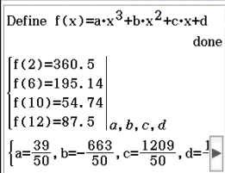
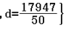
OR
Specific behaviours
correct value for a
correct value for b
correct value for c
correct value for d
(b) Find the coordinates of the point(s) on the track that is furthest from the ground.
(2 marks)
Solution
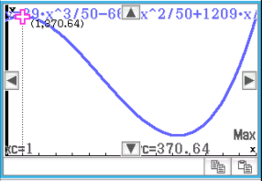$(1, 370.64)$
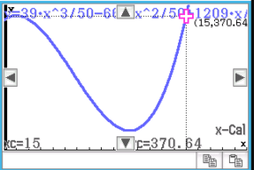$(15, 370.64)$
Specific behaviours
obtains one point and states its coordinates
obtains two points and states their coordinates

END OF QUESTIONS
Additional working space
Question number:

Additional working space
Question number:

Additional working space
Question number:

